The First Presbyterian Church

of Port Gibson, Mississippi

Worship Service April 16, A.D. 2017

Instrumental Prelude Mrs. H.N. Gage
Introit The Choir
Welcome and Announcements
The Doxology No. 572
Invocation and Lord’s Prayer
Responsive Reading No. 623
Hymn of Praise (All) No. 165
The Apostles’ Creed (Front of Hymnal)
The Gloria Patri No. 576
Time with the Children / Minute for Mission
Hymn of Meditation (All) No. 168
****
Silent Prayer and Meditation
The Pastoral Prayer
Choral Response
****
Offering and Offertory Prayer
Scripture I Corinthians 15:1-26 (p. 850, p.)
Sermon “Why the Resurrection Matters”
Hymn of Dedication (All) No. 163
Benediction
Response The Choir
Postlude

We extend our sincere welcome to our visitors.
Please come to worship with us again, soon.

CHILDREN in second grade or younger are welcome to attend Children’s Church after the Time with God’s Children.

IF YOU DESIRE TO BECOME A MEMBER of this congregation of the
Body of Christ, please speak to the pastor after the Worship Service.

Announcements

WE WELCOME Jim and Diane Harrison and Scott Harrison to the membership of this congregation. They come by transfer of letter from Minnetonka United Methodist Church in Minnetonka, Minnesota.

CHURCH PLANTS sponsored by our presbytery include Quest Church in New Braunfels, Texas: www.questchurchnb.com and All Souls’ Church in Austin, Texas: http://www.landofmysojourn.com To help with these efforts, make out your check to First Presbyterian Church and label it either “Quest Church” or “All Souls’ Church.”

PLEASE PRAY for Nick and Amanda, and Nour and Rebecca as they participate in the Engage 2025 project in the Middle East. To help, make out your check to First Presbyterian Church and label it either “Nick and Amanda” or “Nour and Rebecca.”

PLEASE PRAY for Andrew Brunson, an EPC Teaching Elder who has been unjustly imprisoned in Turkey. You can find more information at https://www.epc.org/forgottenamericaninturkey

Opening and Closing Schedule

4/16-22 – Eddie Lipscomb 5/14-20 – Shreve Guthrie, III
4/23-29 – Lem Montgomery 5/21-27 – Don Wilson
4/30-5/6 – John L. Torrey 5/28-6/3 – Scott Davis
5/7-13 – Doug Nasif 6/4-10 – Michelle Burrell
6/11-17 – Kenny Strawn

Upcoming Events

April 28-29 Presbytery Meeting, First Ocean Springs
May 4-7 Presbyterian Cursillo, Camp Wesley Pines
May 7 Spring Grand Gulf Outing, 10:30am
May 19 PG Heritage Trust Progressive Dinner
June 10 Chamber of Commerce Car Show
June 20-23 EPC General Assembly, Sacramento, CA
September 22-23 Presbytery Meeting, Christ EPC Houston
October 1 Fall Grand Gulf Outing, 10:30am
November 2-5 Presbyterian Cursillo, Camp Wesley Pines

Bible Reading Schedule

April 17 Romans 1:1-17 – Mutually Sharing the Gospel of Christ
April 18 Romans 5:1-5 – Fruit of Justification by Faith
April 19 Romans 5:12-21 – Grace Abounded through Jesus Christ
April 20 II Corinthians 11:16-33 – Paul’s Faithful Ministry despite Suffering
April 21 Romans 8:18-25 – Believers’ Present Suffering and Future Glory
April 22 Romans 8:26-30 – God’s Will Shapes Human Direction
April 23 Romans 5:6-11; 8:31-39 – God’s Love Never Changes

April Birthdays

1 Sonya Byrnes 4 Becky Nasif
5 Elaine Styron 7 Al Hollingsworth
17 Lee Eaton 19 Sarah Noble
20 Julie Strawn Brown 21 Jason Cassell
21 Dawn Eaton 24 Kit Torrey Mayfield
25 Lee Hynum 26 Andy Cassell
28 Sarah Hudson 30 Brady Noble

Church Directory

Rev. Michael G. Herrin, Pastor
Mrs. H.N. Gage, Organist

The Session

Class of 2017 Class of 2018 Class of 2019
Mr. Burton O. Byrnes, II Mr. Gary Knight Mr. Kenny Strawn
Mr. Douglas Nasif Mr. Lem Montgomery Mr. John L. Torrey

The Diaconate

Class of 2017 Class of 2018 Class of 2019
Mr. Jimmy Cassell Mr. Jim Hynum Shreve Guthrie, III
Dr. Eddie Lipscomb Mr. Mack May Kevin Keaton
Mr. Mike Mikell

Presbyterian Women

Mrs. Dianne Wade, Moderator Dr. Betsy Lipscomb, Mission Representative
Mrs. Jo Ann Mikell, Vice-Moderator Mrs. Azalea Knight, Secretary/Treasurer

Deacon for the Month: Mack May
Tithes and offerings may be mailed to P.O. Box 517.
CD recordings of services are available. Call the pastor at 5887.

Through fellowship, teaching and service,
sharing the truth of Jesus Christ
with one another, with the community, and with the world.

The First Presbyterian Church

PORT GIBSON, MISSISSIPPI
ORGANIZED 1807
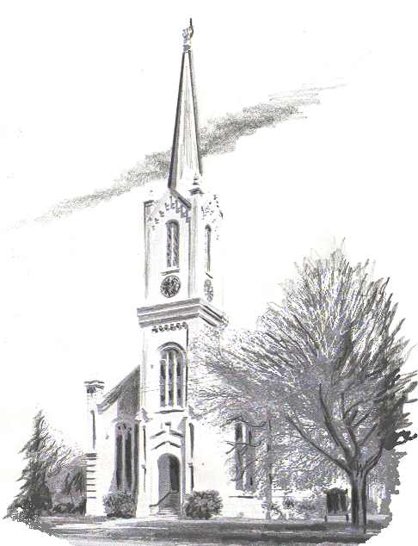

Website: www.fpcportgibson.com Study Telephone: 437-5428
Manse Address: 1101 Church Street Manse Telephone: 437-5887

